K-Nearest Neighbor Algorithm

Code for loading dataset into 2D python list: here

Dataset preparation:
Randomly Split the dataset into Training (70%), Validation (15%) and Test (15%) set
Train_set=[], Val_set=[], Test_set=[]
//Shuffle your dataset list
1. for each sample S in the dataset:
2. generate a random number R in the range of [0,1]
3. if R>=0 and R<=0.7:
4. append S in Train_set
5. elif R>0.7 and R<=0.85:
6. append S in Val_set
7. else:
8. append S in Test_set

KNN Classification:
Use Iris data iris,
K = 5
1. for each sample V in the VALIDATION set:
2. for each sample T in the TRAINING set:
3. Find Euclidean distance between Vx (features->N-1) and Tx (features->N-1)
4. Store T and the distance in list L
5. Sort L in ascending order
6. Take the first K samples
7. Take the majority class from the K samples (this is the detected class for sample V)
8. Now, check if this class is correct or not
9. Calculate validation_accuracy = (correct VALIDATION samples)/(total VALIDATION samples) * 100

- Calculate validation accuracy in a similar way for K = 1, 3, 5, 10, 15
- Make a table with 2 columns: K and Validation Accuracy (report template)
- Now, take the K with highest Validation Accuracy
- Use this best K to determine Test Accuracy (Simply replace the VALIDATION set of line 1. with TEST set)

KNN Regression:
Use diabetes data diabetes
K = 5, Error = 0
1.for each sample V in the VALIDATION set:
2. for each sample T in the TRAINING set:
3. Find Euclidean distance between Vx and Tx
4. Store Tx and the distance in list L
5. Sort L in ascending order
6. Take the first K samples
7. Take the average output of the K samples (this is the determined output for sample V)
8. Error = Error + (V true output - V determined output)^2
9.Calculate Mean_Squared_Error = Error/(total number of samples in VALIDATION set)

- Calculate Mean_Squared_Error in a similar way for K = 1, 3, 5, 10, 15
- Make a table with 2 columns: K and Mean_Squared_Error (report template)
- Now, take the K with minimum Mean_Squared_Error
- Use this best K to determine Mean_Squared_Error for the Test set (Simply replace the VALIDATION set of line 1. with TEST set)

Instruction
- Submit the .ipynb file and a report (report template) .pdf file.
- DO NOT USE LIBRARIES SUCH AS: "Sklearn", "Scikit learning" or "pandas" for this assignment
- Copying will result in -100% penalty

Marks Distribution
(1) Dataset loading: 1.5
(2) Train, Validation, Test split: 2.5
(3) KNN classification algorithm + K tuning (table) + test accuracy : 5 + 1.5 + 1.5
(4) KNN regression algorithm + K tuning (table) + test mean squared error : 5 + 1.5 + 1.5

Dataset description:

Diabetes
[source: Diabetes dataset, sklearn.datasets.load_diabetes — scikit-learn 1.1.1 documentation]
Number of Instances: 442
Number of Attributes: First 10 columns are numeric predictive values
Target: Column 11 is a quantitative measure of disease progression one year after baseline
Attribute Information:
- age in years
- sex
- bmi body mass index
- bp average blood pressure
- s1 tc, total serum cholesterol
- s2 ldl, low-density lipoproteins
- s3 hdl, high-density lipoproteins
- s4 tch, total cholesterol / HDL
- s5 ltg, possibly log of serum triglycerides level
- s6 glu, blood sugar level
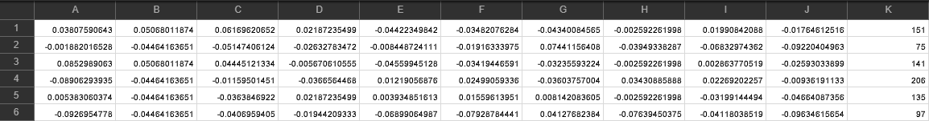

Iris:
Source [7.1. Toy datasets — scikit-learn 1.1.1 documentation ]
Number of Instances 150 (50 in each of three classes)
Number of Attributes 4 numeric, predictive attributes and the class
Attribute Information
- sepal length in cm
- sepal width in cm
- petal length in cm
- petal width in cm
- class:
  - Iris-Setosa
  - Iris-Versicolour
  - Iris-Virginica

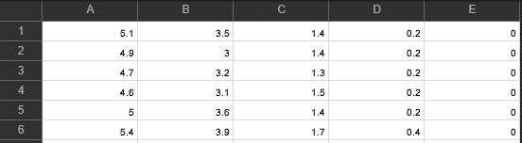

Resources
7.1. Toy datasets — scikit-learn 1.0.2 documentation

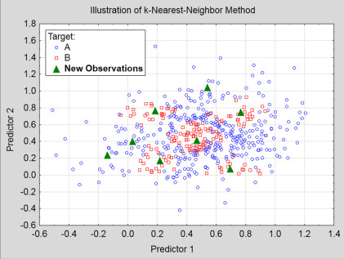
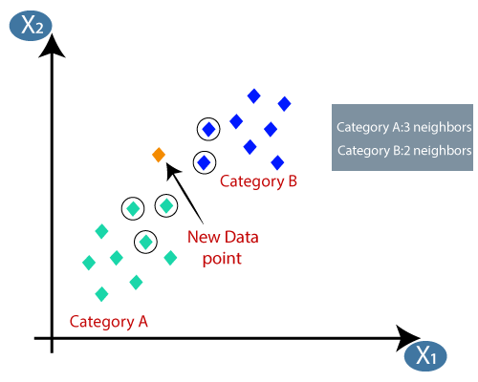

- Dataset (samples, features/attributes, label/classes)
  - iris, diabetes
- Model high level concept from the perspective of supervised learning

- supervised learning, Classification, Regression
- dataset -> train, val, test

- KNN high level overview
- KNN pseudocode
- Instructions

- Classification: majority
- Regression: squared error

